Event Name:__________________________________________________________________________

Event Organizer:___________________________________________________________________

Mailing Address: _______________________________________________________________________

City: ________________________State:______________________Zip___________________________

Email Address:________________________________________________________________________

Event Contact Phone: __________________________________________________________________

Type of Event:________________________________ Public or Private

Date of Event: ________________________________ Time:_____________ To ______________

Number of people expected_____________

**Rules for use of the facility**

* Events hosted at the museum shall not endanger its exhibits or collections. Exhibits may not be moved or altered in any way to accommodate an event.
* Hosts must take their garbage with them. Cans and liners will be provided, but garbage must be removed at the end of the event.
* Sales of alcohol and food require licensing by the appropriate authorities.
* The kitchenette is provided as a courtesy and is not designed for cooking.
* Event hosts must provide their own tablecloths, plates, cups etc.
* Use of candles, glitter, and confetti are prohibited.
* Event organizers agree to leave the premises in the same condition as when they arrived. Typical cleaning supplies can be made available.
* Events for children must have adequate adult supervision.
* Fees are: one day $250, two; two days $400, three days $600. Beyond that, fee set by Director. An additional $25/hour outside normal business hours for staffing.
* Organizers must provide a 10% non-refundable deposit to secure the date of their function, the remaining fee must be paid within five business days in advance of the event. Checks should be payable to the Churchill County Museum Association. A returned check fee of $35 will be charged for any returned check which is returned to the Association as unpaid for any reason by the host’s bank or financial institution.
* Event hosts agree to hold harmless and indemnify the Churchill County Museum Association, its Board of Directors, volunteers, agents or insurers, and Churchill County, its employees, officers, agents or insurers for any claims, losses, liabilities, damages, costs or expenses incurred as a result of any claims or suits that may arise from the hosted event at the museum.
* Early setup or late cleanup allowed with prior approval.

I hereby certify that I am 18 years of age and an authorized representative of the Event organizer and may enter into legal agreements on its or my behalf.

_____________________________________________ ____________ ___

Event Organizer Date

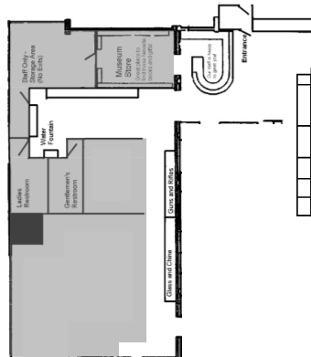

Event Space Capacity:

Sit down w/Tables = 100

Chairs only = 200

Standing = 300

How many tables and chairs would you like to use?

Please include the following in my rental agreement:

____ 5’ Round Tables (17 available)

____ 6’ Round Tables (1 available)

____ 6’ X 30” Rectangular Tables (6 available)

____ 8’ X 30” Rectangular Tables (5 available)

____ 32” X 43” Cocktail Tables (6 available)

____ Banquet Chairs (150 available)

____ Tablecloths $5 each (for formal event only)

____ 15’ X 15’ Dance Floor $250

____ Photo Booth $150 plus $.75 per print

____I would like to use the museum’s digital projector and screen

____I would like to use the museum’s PA system

|  |  |  |
| --- | --- | --- |
| Non Refundable Deposit Paid 10% | Payment Method Reference | Date: |
| Fee Paid | Payment Method Reference | Date: |

Revised January 1, 2023